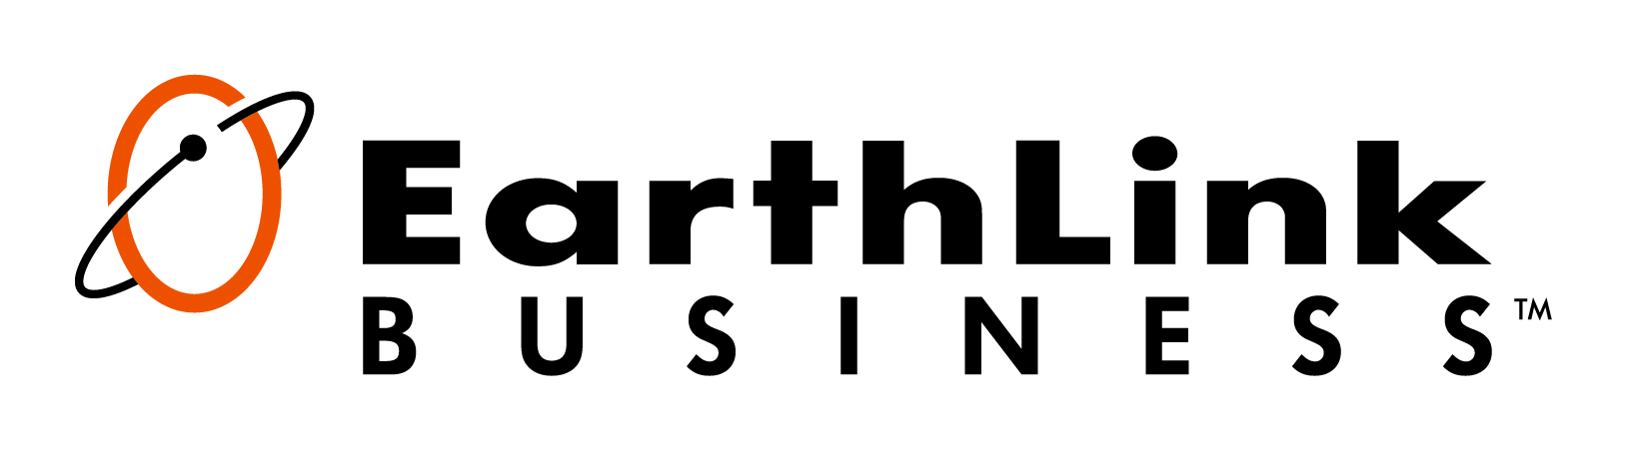
Company’s Custom Business Solution

Insert Partner Logo if desired.
Delete green highlighted text before presentation.
Authorized EarthLink Partner

www.earthlinkbusiness.com
Who We Are
EarthLink Business offers nationwide reach with a local touch
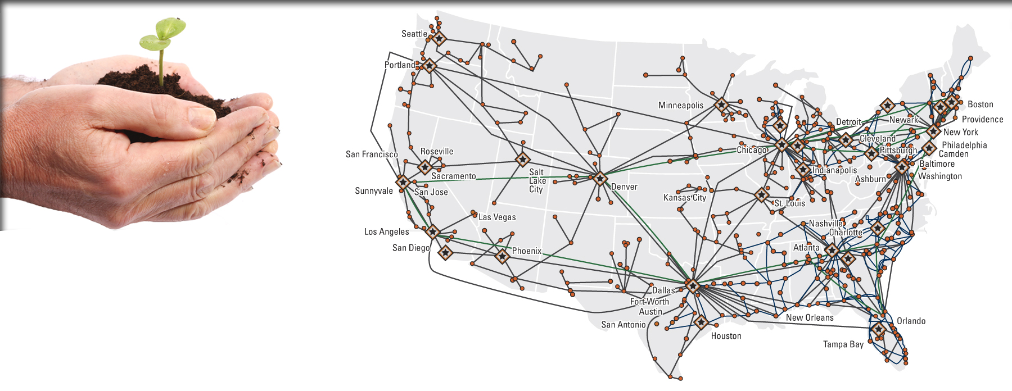
Since the 1990s, EarthLink has
made it easier for people to harness
the power of technology to enhance their
business.
Partner Name, in partnership with EarthLink Business, is committed to delivering on these core
corporate beliefs by enabling businesses to harness the power of technology while nurturing strong customer relationships through consistent, transparent communication and solicitation of continuous feedback. Your EarthLink Business team excels at:
- Ensuring our customer experience exceeds expectations
- Collaborating with our customers on a regular basis
- Building businesses, relationships and careers
- Enabling our customers to fully leverage technology

What We Do
We provide the exact solution you need…no more, no less
The details of your communications solution can be confusing if they are not part of your daily life. From networks, PRI and cloud solutions to MPLS, DID and SIP Trunking, we will clarify your technology needs and make the complex simple and easy to understand.
You’re an expert? We’ll explain your specific solution in detail and make sure all your technical questions are answered.
This technology isn’t your specialty? Don’t worry…it is ours. We’ll take care of the complexities behind the scenes then explain everything to you at a high level.
We make this easy so you can focus on the things that matter most to you.

Company Objectives
Customized solutions designed around your specific business need

ATTENTION: State the objectives discussed in the discovery process and how the solution will solve the customer’s challenges – this should reflect dominate buying motivates (not the technology request). Delete green highlighted text before presentation.
Objectives | Achieved with EarthLink Business
A consultative approach with a dedicated person to contact you at least three times per year to:  - Answer questions  - Keep you informed of the latest technologies  - Conduct ongoing needs assessments that keep pace with your company’s goals | We believe in a business partner approach and I will ensure you receive the consultations, needs assessments and new technology briefings you require to ensure your business thrives.
Add “Internal dialing” between the corporate and warehouse employees to:  - Minimize call transfers and hold times  - Improve customer service and employee productivity | - Simple 4 digit dialing between sites  - Main Internet for both sites as well as a secure platform for the online store  - Includes long distance (1,500 minutes), which reduces costs and suppliers.
Greater voice/phone capacity to provide better service for customers who need to contact warehouse employees directly | - Increased phone and voice capacity  - Enhanced customer service with a dedicated phone number/line for the warehouse and corporate office

Company’s Proposed Solution
Designed specifically with your business needs in mind

Nationwide Voice
Things like the type of phones you use and who you communicate with helped us determine the connection type(s) we selected for you.
Monthly Solution Investment = $0.00
X | Solutions
 | Local and/or long distance
 | Hosted voice (includes phones)
 | Integrated/Bundled voice and data
 | Mobile
 | Conferencing

IT SERVICES
We identified a need to help your IT department run applications (i.e. Microsoft Exchange) off site, protect your assets, ensure security compliance and/or host your IT computing infrastructure.
X | Solutions
 | Data Center
 | Virtualization
 | Security
 | Applications
 | Support / Managed Services
Monthly Solution Investment = $0.00

Nationwide DATA
Based on your number of offices, where they’re each located in the country and your concerns with speed, reliability and security we selected the option(s) below that meet your requirements.
X | Solutions
 | Multiprotocol Label Switching (MPLS)
 | Internet access
 | Managed security
Monthly Solution Investment = $0.00

EQUIPMENT AND SYSTEMS
When phone equipment is needed, the specific type of business you have and your employee responsibilities and management needs guided this proposed solution.
X | Solutions
 | IP telephony/messaging
 | Contact center
 | Unified Communications (UC)
 | Preferred Maintenance Agreement
Monthly Solution Investment = $0.00

Multiple Access Methods
We determined whether it was more common at your business to download (i.e. You Tube) or upload (i.e. send files to other locations), and have found the perfect access method for each of your locations.
X | Solutions
 | DSL – high download speeds and low upload speeds
 | T-1 – medium upload and download speeds with high priority repair times
 | Ethernet – top of the line connection for extremely high bandwidth and support needs
 | Wireless – backup connection for disaster recovery and/or for your remote or mobile workforce
Total Monthly Solution Investment = $0.00
*Access investment included in section subtotals. Estimates may not include all applicable charges. Taxes and surcharges not included.

Thank You
We know you have a choice of providers and appreciate you considering our team
Thank you for taking the time to review your custom communications solution. This was created specifically for you based on our assessment of your company’s needs. We are confident in its power to make your business successful.
We look forward to having you as a valued customer.

Your Personal Account Team
Ensuring you will have all the support you need from this moment forward


sales TEAM

Representative | Rep Name | email@corp.earthlink.com | xxx-xxx-xxxx
Manager | Manager Name | email@corp.earthlink.com | xxx-xxx-xxxx

CUSTOMER Support TEAM

EarthLink Business Customer Care | Care Team Member | customercare@corp.earthlink.com | Enter toll free #
Personal Customer Account Manager | Account Manager Name | email@corp.earthlink.com | xxx-xxx-xxxx
Customer Successes
Learn the extent of our commitment to an excellent customer experience
Customize or remove this section as needed (or keep it as is). Delete green highlighted text before presentation.
These are just three of our many happy customers. Learn more on our website at earthlinkbusiness.com/about-us/ourcustomers.xea.

“GNC has lowered payment card processing fees,
saves over $300,000 annually by eliminating phone lines and
now supports critical retail applications with their
EarthLink Business MPLS network.”
– Jerry Werner, VP and CIO, GNC


“Our improved business efficiency, not to mention the upgraded experience we can now provide to our customers, validates my confidence in
the decision to select EarthLink Business.”
– April Holley, Director of IT for Edgewater Beach & Golf Club Resort


“EarthLink Business’ attention to detail with their technical [cloud] solutions and their customer-focused service is the perfect
solution for our needs; reliability and up-time are a must for
our web presence and they know how to deliver. My
only wish is that we made the switch earlier.”
– Eric Miltsch, IT/Internet Director, Auction Direct USA
Optional Additional Page/Section
This section is for additional information you may want to include. Some suggestions are:
- Financial information
- Next steps / Implementation
- Customer references/referrals
- ROI Calculator (“Potential Benefits” example below)

sub-Heading 1
Lorem ipsum dolor sit amet, consectetur adipiscing elit. Sed sapien lorem, eleifend quis facilisis vestibulum, malesuada malesuada nulla. Nunc bibendum varius metus, quis rutrum nunc tempor in. Phasellus pretium diam sit amet nunc varius scelerisque. Proin elit turpis, ultrices sit amet placerat id, egestas sed purus. Suspendisse potenti. Curabitur dictum metus nec massa rutrum at vestibulum ipsum sollicitudin. Sed blandit nisl at mauris venenatis iaculis.
Company’s Potential Benefits [OPTIONAL SECTION]
Based upon our discussion, if you utilize this EarthLink Business solution we estimate your sales personnel will have greater productivity, translating into additional sales revenue.
Assumptions
The following assumptions were made to calculate your potential revenue increase:
Average sale per representative | $2,000
Conservative estimate | 20% of your Sales Representatives close one additional sale per month
Very conservative estimate of increased cash flow | $[insert amount]/month (# Sales Reps x $2,000 per sale)
Calculation
Using a very conservative estimate, this could translate into:
Potential sales revenue increase | $[insert amount] per month

---Delete entire section if not needed---

Optional Additional Page/Section
This section is for additional information you may want to include. Some suggestions are:
- EarthLink financial information
- Next steps / Implementation
- Customer references/referrals
- ROI Calculator (“Potential Benefits” example below)

sub-Heading 1
Lorem ipsum dolor sit amet, consectetur adipiscing elit. Sed sapien lorem, eleifend quis facilisis vestibulum, malesuada malesuada nulla. Nunc bibendum varius metus, quis rutrum nunc tempor in. Phasellus pretium diam sit amet nunc varius scelerisque. Proin elit turpis, ultrices sit amet placerat id, egestas sed purus. Suspendisse potenti. Curabitur dictum metus nec massa rutrum at vestibulum ipsum sollicitudin. Sed blandit nisl at mauris venenatis iaculis.
Company’s Potential Benefits [OPTIONAL SECTION]
Based upon our discussion, if you utilize this EarthLink Business solution we estimate your sales personnel will have greater productivity, translating into additional sales revenue.
Assumptions
The following assumptions were made to calculate your potential revenue increase:
Average sale per representative | $2,000
Conservative estimate | 20% of your Sales Representatives close one additional sale per month
Very conservative estimate of increased cash flow | $[insert amount]/month (# Sales Reps x $2,000 per sale)
Calculation
Using a very conservative estimate, this could translate into:
Potential sales revenue increase | $[insert amount] per month

---Delete entire section if not needed---

